1. Identification

Product identifier used on the label: | ARRIBA TWIST KIWI GRAPEFRUIT
Stock Number:
Other means of identification:
Synonyms: |  | None

Recommended use of the chemical and restrictions on use:
Recommended use: | Liquid Odor Counteractant
Restrictions on use: | Uses other than recommended use.

Name, address, and telephone number of the chemical manufacturer, importer, or other responsible party: | AIR-SCENT INT'L  RIDC INDUSTRIAL PARK  290-298 ALPHA DRIVE  PITTSBURGH, PA 15238
Telephone number: | EMERGENCY PHONE: (800) 535-5053  INFORMATION PHONE: 800-247-0770  INFORMATION FAX: 412-252-1010  IF SWALLOWED CALL YOUR POISON  CONTROL CENTER AT 1-800-222-1222
E-mail address:
Emergency phone number:

2. Hazard(s) identification

Classification of the chemical in accordance with paragraph (d) of §1910.1200:

GHS Hazard Symbols: |  | 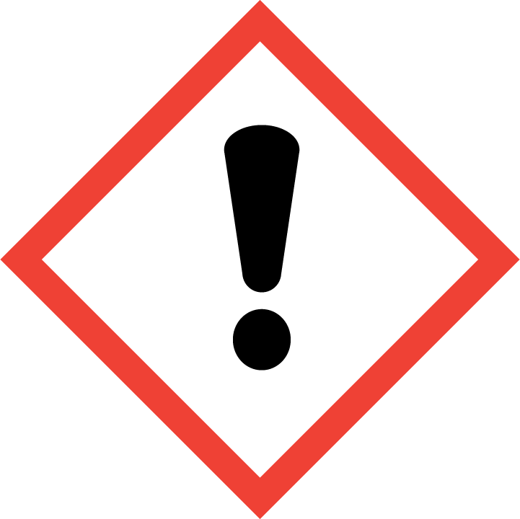
GHS Classification: |  |  | Skin Sensitisation Category 1B  Skin Corrosion/Irritation Category 2  Serious Eye Damage/Eye Irritation Category 2A  Flammable Liquid Category 4
Signal Word: |  |  | Warning
Hazard Statements: |  |  | Combustible liquid  Causes skin irritation.  May cause an allergic skin reaction.  Causes serious eye irritation.
Precautionary Statements:
Prevention: |  |  | Keep away from heat/sparks/open flames/hot surfaces. – No smoking. Avoid breathing dust/fume/gas/mist/vapors/spray. Wash thoroughly after handling. Contaminated work clothing should not be allowed out of the workplace. Wear protective gloves/protective clothing/eye protection/face protection.
Response: |  |  | If on skin: Wash with plenty of water. If in eyes: Rinse cautiously with water for several minutes. Remove contact lenses, if present and easy to do. Continue rinsing. If skin irritation or rash occurs: Get medical advice/attention. If eye irritation persists: Get medical advice/attention. Take off contaminated clothing and wash it before reuse. Wash contaminated clothing before reuse. In case of fire: Use an approprate extinguisher (see section 5) for extinction.
Storage: |  |  | Store in a well-ventilated place. Keep cool.
Disposal: |  |  | Dispose of contents/container to a suitable disposal site in accordance with local/national/international regulations.

Hazards not otherwise classified: | None Known

3. Composition/information on ingredients

Chemical Name | Common name and synonyms | CAS # | %
3-Octanol, 3,7-dimethyl- | None | 78-69-3 | 10 - 30
Decanal | None | 112-31-2 | 7 - 15
7-Octen-2-ol, 2,6-dimethyl- | None | 18479-58-8 | 5 - 10
Naphthalene, 2-methoxy- | None | 93-04-9 | 1 - 5
3-Cyclohexene-1-carboxaldehyde, 2,4-dimethyl- | None | 68039-49-6 | 1 - 5
Octanal | None | 124-13-0 | 0.5 - 1.5
Butanoic acid, 3-methyl-, ethyl ester | None | 108-64-5 | 0.5 - 1.5
CITRAL 95 - C-1161 | None |  | 0.1 - 1
Dodecanal | None | 112-54-9 | 0.1 - 1

One or more hazardous ingredient(s) is claimed as a trade secret under the OSHA Hazard Communication Standard. The hazards of this (these) ingredient(s) are given on this SDS.

4. First-aid measures

Description of necessary measures, subdivided according to the different routes of exposure, i.e., inhalation, skin and eye contact, and ingestion:
Inhalation: | Remove to fresh air. If breathing is difficult, have a trained individual administer oxygen.
Eye Contact: | Use an eye wash to remove a chemical from your eye regardless of the level of hazard. Flush the affected eye for at least twenty minutes. Tilt the head to prevent chemical from transferring to the uncontaminated eye. Seek medical advice after flushing.
Skin Contact: | Wash with soap and water. Get medical attention if irritation develops or persists.
Ingestion: | Minimal risk of harm if swallowed. Do not induce vomiting. Seek medical attention immediately. Provide medical care provider with this MSDS.
Most important symptoms/effects, acute and delayed: | Causes skin irritation May cause an allergic skin reaction Causes serious eye irritation
Indication of immediate medical attention and special treatment needed, if necessary: | None Known

5. Fire-fighting measures

Suitable (and unsuitable) extinguishing media:
Suitable extinguishing media: | Use alcohol resistant foam, carbon dioxide, or dry chemical extinguishing agents. Water may be ineffective but water spray can be used extinguish a fire if swept across the base of the flames. Water can absorb heat and keep exposed material from being damaged by fire.
Unsuitable extinguishing media: | None Known
Specific hazards arising from the chemical: | Vapors may be ignited by sparks, flames or other sources of ignition if material is above the flash point giving rise to a fire (Class B). Vapors are heavier than air and may travel to a source of ignition and flash back. Combustible
Hazardous combustion products: | Carbon Oxides
Special protective equipment and precautions for fire-fighters: | Do not enter fire area without proper protection including self-contained breathing apparatus and full protective equipment. Fight fire from a safe distance and a protected location due to the potential of hazardous vapors and decomposition products. Use methods for the surrounding fire. Flammable component(s) of this material may be lighter than water and burn while floating on the surface.

6. Accidental release measures

Personal precautions, protective equipment and emergency procedures: | No health affects expected from the clean-up of this material if contact can be avoided. Follow personal protective equipment recommendations found in Section VIII of this MSDS
Methods and materials for containment and cleaning up: | No special spill clean-up considerations. Collect and discard in regular trash.

7. Handling and storage

Precautions for safe handling: | Mildly irritating material. Avoid unnecessary exposure. Use spark-proof tools and explosion-proof equipment
Conditions for safe storage, including any incompatibilities:
Safe storage conditions: | Store in a cool dry place. Isolate from incompatible materials. Keep away from sources of ignition
Materials to Avoid/Chemical Incompatibility: | Strong oxidizing agents, Strong reducing agents, Strong bases, Oxidising agents, Strong acids, Acids, Bases, Reducing agents, Oxidizing materials, Strong alkalies, Acid chlorides, Acid anhydrides

8. Exposure controls/personal protection

OSHA permissible exposure limit (PEL), American Conference of Governmental Industrial Hygienists (ACGIH) Threshold Limit Value (TLV), and any other exposure limit used or recommended by the chemical manufacturer, importer, or employer preparing the safety data sheet, where available:

Chemical component | OSHA PEL | ACGIH TLV | ACGIH STEL | IDLH
No Data Available

Appropriate engineering controls: | No exposure limits exist for the constituents of this product. General room ventilation might be required to maintain operator comfort under normal conditions of use.
Individual protection measures, such as personal protective equipment:
Respiratory Protection: | No respiratory protection required under normal conditions of use. Provide general room exhaust ventilation if symptoms of overexposure occur as explained Section III. A respirator is not normally required.
Eye protection: | Wear safety glasses when handling this product.
Skin protection: | Not normally considered a skin hazard. Where use can result in skin contact, practice good personal hygiene and wear a barrier cream and/or impervious surgical style gloves. Wash hands and other exposed areas with mild soap and water before eating, drinking, and when leaving work.
Gloves: | No information available
General hygiene conditions: | Wear protective gloves/protective clothing/eye protection/face protection. Contaminated work clothing should not be allowed out of the workplace. Wash thoroughly after handling.

9. Physical and chemical properties

Appearance (physical state, color etc.):
Physical state: | Liquid
Color: | Very pale yellow
Odor: | CITRUS
Odor Threshold: | Not determined
pH: | Not applicable
Melting point/freezing point:
Melting Point: | -9 º F
Freezing point: | No Data Available
Initial boiling point and boiling range: | 160 - 163 º F
Flash Point: | 145 º F
Evaporation Rate: | Not determined
Flammability (solid, gas): | No Data Available
Upper/lower flammability or explosive limits:
Upper flammability or explosive limits: | Not Available
Lower flammability or explosive limits: | Not Available
Vapor pressure: | No Data Available
Vapor density: | > 1
Relative density: | 1
Solubility(ies): | Soluble in water- No
Partition coefficient: n-octanol/water: | No Data Available
Auto-ignition temperature: | 200 º C
Decomposition temperature: | No Data Available
Viscosity: | No Data Available
Volatile Organic Chemicals: | 69.67
Bulk Density: | 7.001

10. Stability and reactivity

Reactivity: | Not expected to be reactive
Chemical stability: | Stable under normal conditions.
Possibility of hazardous reactions: | None expected under standard conditions of storage
Conditions to avoid (e.g., static discharge, shock, or vibration): | Temperatures above flash point in combination with sparks, open flames, or other sources of ignition. direct sunlight Extremes of temperature sparks flame Heat
Incompatible materials: | Strong oxidizing agents, Strong reducing agents, Strong bases, Oxidising agents, Strong acids, Acids, Bases, Reducing agents, Oxidizing materials, Strong alkalies, Acid chlorides, Acid anhydrides
Hazardous decomposition products: | Carbon Oxides

11. Toxicological information
Description of the various toxicological (health) effects and the available data used to identify those effects:

Information on the likely routes of exposure (inhalation, ingestion, skin and eye contact): | Eye contact Skin contact Ingestion Inhalation
Symptoms related to the physical, chemical and toxicological characteristics: | Causes skin irritation May cause an allergic skin reaction Causes serious eye irritation
Delayed and immediate effects and also chronic effects from short- and long-term exposure:

Ingestion Toxicity: | Harmful if swallowed.
Skin Contact: | Can cause minor skin irritation.
Inhalation Toxicity: | Can cause systemic damage (see "Target Organs)
Eye Contact: | Can cause minor irritation, tearing and reddening.
Sensitization: | May cause an allergic skin reaction
Reproductive and Developmental Toxicity: | No Data Available
Carcinogenicity: | No Data Available
STOT-single exposure: | Based on available data, the classification criteria are not met.
STOT-repeated exposure: | Based on available data, the classification criteria are not met.
Aspiration hazard: | Based on available data, the classification criteria are not met.
Numerical measures of toxicity (such as acute toxicity estimates):
Chemical Name | LD50 Oral | LD50 Dermal | LC50 Inhalation
No data available
Is the hazardous chemical is listed in the National Toxicology Program (NTP) Report on Carcinogens (latest edition) or has been found to be a potential carcinogen in the International Agency for Research on Cancer (IARC) Monographs (latest edition), or by OSHA:
Chemical Name | OSHA Carcinogen | IARC Carcinogen | NTP Carcinogen
No Data Available

12. Ecological information

Ecotoxicity (aquatic and terrestrial, where available): | No Data Available
Ecological Toxicity Data:
Chemical Name | CAS # | Aquatic EC50 Crustacea | Aquatic ERC50 Algae | Aquatic LC50 Fish
No Data Available

Persistence and degradability: | No data
Bioaccumulative potential: | No Data Available
Mobility in soil: | No Data Available
Other adverse effects (such as hazardous to the ozone layer): | None Known

13. Disposal considerations

Description of waste residues and information on their safe handling and methods of disposal, including the disposal of any contaminated packaging: | Spent or discarded material is a hazardous waste.
Waste codes / waste designations: | D001

14. Transport information

Carriage of dangerous goods by road (DOT), rail or inland waterways:
UN number: | Not Restricted
UN Proper shipping name: | No Data Available
Transport hazard class(es): | No Data Available
Packing group, if applicable: | No Data Available
DOT Basic description: | No Data Available
International carriage of dangerous goods by sea (IMDG/IMO):
UN number: | Not Restricted
UN Proper shipping name: | No Data Available
Transport hazard class(es): | No Data Available
Packing group, if applicable: | No Data Available
International carriage of dangerous goods by air (IATA):
UN number: | Not Restricted
UN Proper shipping name: | No Data Available
Transport hazard class(es): | No Data Available
Packing group, if applicable: | No Data Available

Environmental hazards (e.g., Marine pollutant (Yes/No)): | No
Transport in bulk (according to Annex II of MARPOL 73/78 and the IBC Code): | No Data Available
Special precautions which a user needs to be aware of or needs to comply with in connection with transport or conveyance either within or outside their premises: | No Data Available

15. Regulatory information

Safety, health and environmental regulations specific for the product in question:
TSCA Status: | All components in this product are on the TSCA Inventory.

Regulated Components:
Chemical Name | CAS # | CERCLA | Sara EHS | Sara 313 | U.S. HAP
No Data Available

Chemical Name | CAS # | California Prop 65 - Cancer | California Prop 65 - Dev. Toxicity | California Prop 65 - Reprod fem | California Prop 65 - Reprod male
No Data Available

Chemical Name | CAS # | Massachusetts RTK List | New Jersey RTK List | Pennsylvania RTK List | Rhode Island RTK List | Minnesota Hazardous Substance List
No Data Available

16. Other information, including date of preparation or last revision.

SDS Prepared by: | CJ
Revision Date: | 06-04-2020
Revision Number: | 37
Reason for revision: | Activated by Document Formulation Generation

Disclaimer: | Important: While the descriptions, data and information contained herein are presented in good faith and believed to be accurate, it is provided for your guidance only. Because many factors may affect processing or application/use, we recommend that you perform an assessment to determine the suitability of the product for your particular purpose prior to use. Nothing herein should be interpreted as a recommendation to infringe existing patents or violate any laws or regulations. No warranties of any kind, either expressed or implied, including fitness for a particular purpose are made regarding the product described. We assume NO responsibility for any injuries resulting from misuse or misapplication of this product or that might be sustained because of inhalation, ingestion, absorption or other contact with this product. In no case shall the descriptions, information, or data provided be considered a part of our terms and conditions of sale. Further, the descriptions, data and information furnished hereunder are given gratis. No obligation or liability for the description, data and information given are assumed. All such being given and accepted at your risk.

